**PORJECT ENDED!**

Current Plan (Review the Completed Tasks): Elect a Topic (Done!) -> Choose all the Features (Done!) -> Make the Use case diagram and use case specification (Done!) -> Make the Class diagrams(Done!)-> Make the Sequence diagram(Done!) -> Make Software Prototype (Done!) + Make Report (We may do them on the same time) -> Make PowerPoint (Done!) -> Practice Presentation (Done!)

Links:

Group Final Report: [CS3342_Group Project Report.docx](https://portland-my.sharepoint.com/:w:/g/personal/hungcchau4-c_my_cityu_edu_hk/EWORs6Zn6H5OqriD3c2UPkMBQeMvGcq3nXP7iaxlt_7R2Q?e=751Wdg)

Group Presentation Slides: [Presentation for CS3342 Software Design1 .pptx](https://portland-my.sharepoint.com/:p:/g/personal/hungcchau4-c_my_cityu_edu_hk/EcaDYqh1xD1KrVGXQwSHNRIB1dsP_hw7udXbKkZ_dcE_RA?e=y65PcG)

Spreadsheet: [CS3342_TimeSheet_Project Team21.xlsx](https://portland-my.sharepoint.com/:x:/g/personal/hungcchau4-c_my_cityu_edu_hk/Eb1loN5PASZPvHnQx1JgeVsBgLahfwzxtG4HOvGQz_WpzA?e=rDK7zw)

Text of Speech: [CS3342 Text of Speech](https://portland-my.sharepoint.com/:w:/g/personal/hungcchau4-c_my_cityu_edu_hk/ESToN2Tz80VPteTb-r3DpicBfZf1qJOyZOe58XikZFsD5A?e=rbaTFt)

Topic: Community marketplace for second-hand good

Unfinished part:

Report

Plan for ppt:

1. Introduction: Cyrus (0.5min)
2. Background & Current Issue: Alex (2min)
3. Objective and function: Cyrus (2min)
4. Prototype: Arnit (2min)
5. Use Case Diagram: Alvis (2min)
6. Class Diagram (Design pattern, Design Principle): Hei (7min)
7. Sequence Diagram: William (3min)
8. Teamwork: Cyrus (0.5min)
9. Overall reflection: Cyrus (0.5min)
10. Conclusion: Cyrus (0.5min)
11. Q & A: All (10min)

Systems

* Login system & registration system: Arnit
* Listing management system: Hei
* Order system: Cyrus
* Searching system: Alex
* Transaction system: William

Inbox system: Hei

* Recommendation System: Cyrus

2nd Group Meeting Summary:

We talk about some changes about the Use case diagram and class diagram and also what we goona do in this week.

1.We have removed a few and added a few more system (8rn)

2.Hei will be focus on making the class diagram. Its hard to for other groupmate to implemented other code into the class diagram.

3.Other groupmates will be responsible for remaking use case diagram and make sequence diagram this week

4.Arnit will make the prototype

5.Hei will send the code later WhatsApp group later.

6.We will have a script for the presentation

3rd Group Meeting Agenda:

1. Talk about the weather
2. (Main Part) Review the stuff that we done (use case diagram, class diagram and sequence diagram)
3. Review and assign work for the report, presentation and text of speech
4. Q&A

Plan for presentation (we can have a script for presentation) we can talk about that on meeting so dw

**Case specification template:**

|  |  |  |
| --- | --- | --- |
| **Use Case Name:** |  | |
| **Actor(s):** |  | |
| **Description:** |  | |
| **Typical Course of Events:** | **Actor Action** | **System Response** |
|  |  |
| **Alternative Courses:** |  | |
| **Pre-condition:** |  | |
| **Post-condition:** |  | |

**Inbox System**

|  |  |  |
| --- | --- | --- |
| **Use Case Name:** | Inbox-Send Message | |
| **Actor(s):** | Seller, Buyer | |
| **Description:** | The Inbox system provide message exchange and transaction-related communications function between sellers and buyers. Seller and Buyer can send text messages, check their inbox, evaluate offers, and perform transaction-related confirmations in user inbox. | |
| **Typical Course of Events:** | **Actor Action** | **System Response** |
| Step 1: Seller receives and evaluates an offer.  Step 3: If the seller or buyer want to checks a specific message  Step 5: If the buyer want to initiates purchase confirmation  Step 7: Buyer selects payment method  Step 9: Buyer provides payment details  Step 11: Buyer confirms whether the order is received | Step 2: System records the response (accept/ decline) and updates the offer status.  Step 4: System will retrieves the message details from the inbox  Step 6: System requests confirmation and records buyer's response.  Step 8: System presents available options and stores the selected method.  Step 10: System validates and records the payment details.  Step 12: System stores confirmation or follows up for clarification. |
| **Alternative Courses:** | All: If message delivery fails, system alerts sender.  5a. If payment method validation fails, system requests re-entry.  11a. If confirmation is not received within a specific time, system sends a reminder. | |
| **Pre-condition:** | Both Seller and Buyer must be registered in the system.  Seller must have valid offers available. | |
| **Post-condition:** | Messages are successfully sent and stored.  Payment details are recorded securely.  Offer and transaction statuses are updated appropriately. | |

Arnit:

|  |  |  |
| --- | --- | --- |
| **Use Case Name:** | Login Account | |
| **Actor(s):** | Buyer, Seller | |
| **Description:** | This use case describes the process for a user to log into their account. | |
| **Typical Course of Events:** | **Actor Action** | **System Response** |
| Step 1: Users enter their email and password. | Step 2: System verifies the email and password.  Step 3: If valid, the system logs the user in and redirects them to the appropriate dashboard.  Step 4: If invalid, the system prompts the user to try again. |
| **Alternative Courses:** | 3a. If the user exceeds the maximum number of login attempts, the system locks the account and requires reset. | |
| **Pre-condition:** | User has an active account. | |
| **Post-condition:** | User is logged into their account. | |

|  |  |  |
| --- | --- | --- |
| **Use Case Name:** | Register Account | |
| **Actor(s):** | Buyer, Seller | |
| **Description:** | This use case describes the process for a new user to register an account. | |
| **Typical Course of Events:** | **Actor Action** | **System Response** |
| Step 1: User enters their name, email, and password.  Step 4: User enters the verification code.  Step 6: User confirms acceptance of terms. | Step 2: System validates the registration information.  Step 3: The system sends a verification code to the email provided.  Step 5: If valid, the system activates the new account. |
| **Alternative Courses:** | 3a. If the verification code is invalid, the system prompts the user to try again. | |
| **Pre-condition:** | User does not have an active account. | |
| **Post-condition:** | A new account is created and activated. | |

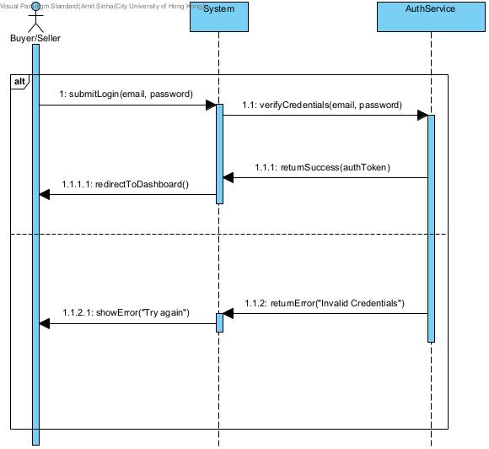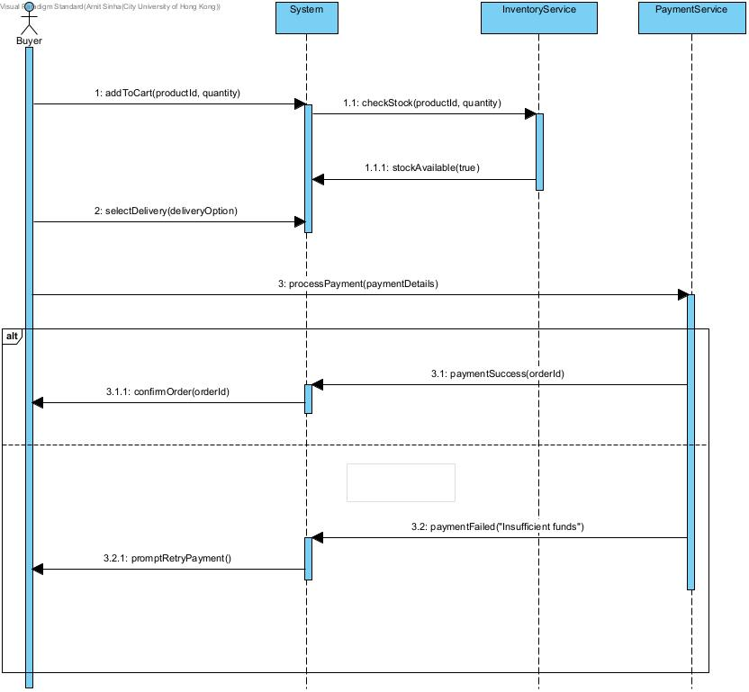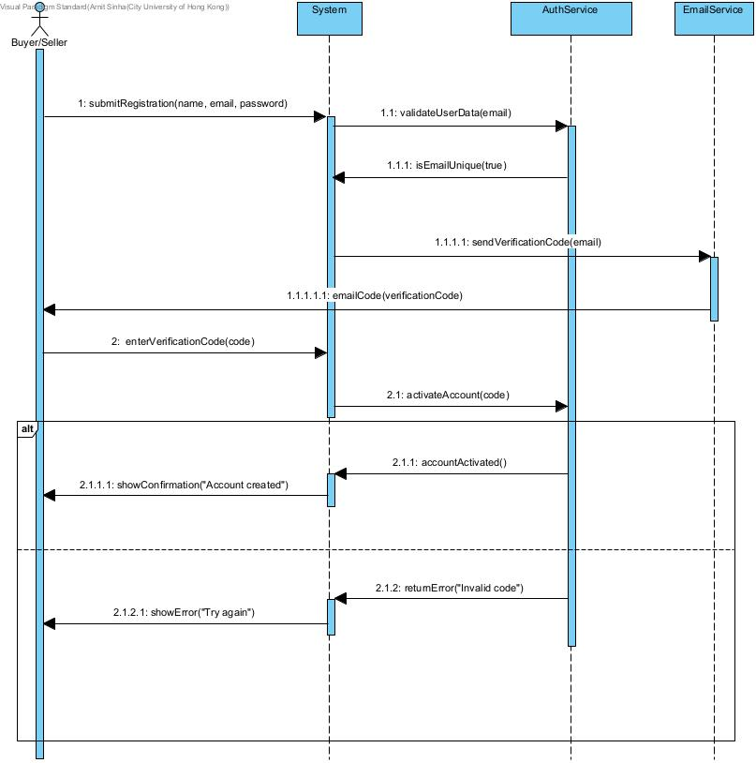

1. Selling system (Hei)

|  |  |  |
| --- | --- | --- |
| **Use Case Name:** | List new item | |
| **Actor(s):** | System role: normal user, context: seller | |
| **Description:** | List new item for sale by specifying various product info | |
| **Typical Course of Events:** | **Actor Action** | **System Response** |
| Step 1: The user clicks “List new item” button  Step 3: The user specifies the required product information. Including,  (1) Category,  (2) condition,  (3) detail,  (4) price,  (5) deal method, and  (6) item photo.  Step 4: Click “Proceed” to proceed to the confirmation page.  Step 6: Click “List now” to list the product. | Step 2: The system directs the user to the “List an item” UI which allows the user to specify the required product information.  Step 5: If all the required product information is specified, direct the user to the “product confirmation page” to double check product info.  Step 7: Send the product information to the “Listing Management System” to list the item to the marketplace. |
| **Alternative Courses:** | Step 5a: If required product information is missing, the system will go back to step 3 and notify the user to specify the required information on top of the missing entries. | |
| **Pre-condition:** | The user has already logged in. | |
| **Post-condition:** | The new item has been successfully listed in the marketplace for sale. The user can view the listing info and status from the “Manage Listings” board. | |

2. Listing management system (Hei)

|  |  |  |
| --- | --- | --- |
| **Use Case Name:** | Manage listings | |
| **Actor(s):** | System role: normal user, context: seller | |
| **Description:** | Enable the user (seller) to manage his/her current listings in one place. Including (1) editing, (2) removing and (3) view status of his/her listed items. Listed items can be organized in various ways using filter. | |
| **Typical Course of Events:** | **Actor Action** | **System Response** |
| Step 1: The user clicks “Manage Listings”.  Step 3: The user selects the operations he/she would like to perform on the selected (“Ticked”) “Listed item”. | Step 2: Direct the user to the “Manage Listings” UI.  Step 4: Response to the user according to the operation selected. |
| **Alternative Courses:** | Step 3a: Using “Filter” to rearrange the order of the displayed listings.  Step 3b: Click “Edit” to edit product information  Step 3c: Click “Remove” to remove the listed item.  Step 3d: Click “View detail” to  Check the status of the listed item. | Step 4a: Display the listings according to the filter.  Step 4b: Allow the user to edit the 6-product information.  Step 4c: Send the “Remove” message to the “Listing Management System” to remove the listed item. The item will be removed from the list in “Manage Listings” UI.  Step 4d: Show the status of the listed item. |
| **Pre-condition:** | At least one item is listed by the user. Otherwise, the list of listings is empty. | |
| **Post-condition:** | If “Edit” is performed. The product information is updated.  If “Remove” is performed. The selected item is removed. | |

Remarks:

“Filter”:

(1) “Category” - TODO

(2) “Date created”, - the date the listing is created.

(3) “Listing Status”- listed, received offer(s), sold but not delivered, sold and delivered, Product confirmed.

(4) “Recently updated”- recent changes of status of a listing.

(5) “Price”- initial expected price specified by the seller.

“6-product information”:

(1) Category,

(2) condition,

(3) detail,

(4) price,

(5) deal method,

(6) item photo.

**Alvis: (**Admin System

**Alex :** Search System

|  |  |  |
| --- | --- | --- |
| **Use Case Name:** | Search Listing | |
| **Actor(s):** | Buyer | |
| **Description:** | This use case describes how a visitor/ potential buyer can search for listings and how the system responds | |
| **Typical Course of Events:** | **Actor Action** | **System Response** |
| Step 1: The user enters the text box and inputs a search query | Step 2: The system dictates if the query is empty, one word, or multiple words.  Step 3: The system looks for all listings with an exact word match and/or tag match for each combination of the input query.  Step 4: The system sends back all matched listings and handles the event of 0 search results  Step 5: The system redirects the user to the visualization of all matching listings. |
| **Alternative Courses:** | Step 2a: If the query is empty, send the error message to the user  Step 5a: redirect to the search page with an error message of 0 search results | |
| **Pre-condition:** | None | |
| **Post-condition:** | None | |

|  |  |  |
| --- | --- | --- |
| **Use Case Name:** | Make payment | |
| **Actor(s):** | Buyer, CreditCardPaymentSystem, AlipayPaymentSystem, PayPalPaymentSystem | |
| **Description:** | The buyer can make a payment. | |
| **Typical Course of Events:** | **Actor Action** | **System Response** |
| Step 1: Buyer clicks the "Make Payment" button.  Step 3: The buyer is prompted to select a payment method (Credit Card, Alipay, PayPal). | Step 2: System will calculate the total amount that the buyer selected in the shopping cart.  Step 4: The system processes the payment through the chosen payment gateway (CreditCardPaymentSystem, AlipayPaymentSystem, or PayPalPaymentSystem).  Step 5: After the system receives the payment, it will hold the funds in escrow until the buyer receives the item or until a period of 2 weeks has passed. |
| **Pre-condition:** | The buyer adds the products into the shopping cart | |
| **Post-condition:** | The payment is paid, and the system hold the fund in escrow | |

|  |  |  |
| --- | --- | --- |
| **Use Case Name:** | Confirm purchase | |
| **Actor(s):** | Buyer | |
| **Description:** | After the seller accepts the offer from the buyer, the buyer has one more opportunity to confirm the purchase. Upon confirmation, the system will proceed to the payment step for the buyer to complete the transaction. | |
| **Typical Course of Events:** | **Actor Action** | **System Response** |
| Step 1: After the buyer confirms their intention to buy the item from the seller, they press the "Confirm Purchase" button. | Step 2: The system proceeds to the payment step for the buyer to complete the purchase. |
| **Pre-condition:** | The seller has accepted the offer from the buyer. | |
| **Post-condition:** | The buyer is directed to the payment page to complete the purchase. | |

|  |  |  |
| --- | --- | --- |
| **Use Case Name:** | Confirm order received | |
| **Actor(s):** | Buyer | |
| **Description:** | After the buyer receives the item from the seller, buyer can confirm the order has been received. | |
| **Typical Course of Events:** | **Actor Action** | **System Response** |
| Step 1: After the buyer confirms order receipt, the buyer presses the “Order Received” button. | Step 2: The system recognizes that the seller has received the item and processes the payment to the seller. |
| **Pre-condition:** | The buyer has received the items from the seller. | |
| **Post-condition:** | The system acknowledges that the seller has received the item and sends the payment to the seller. | |

|  |  |  |
| --- | --- | --- |
| **Use Case Name:** | Make offer | |
| **Actor(s):** | Buyer | |
| **Description:** | If the buyer are interested in the item, he can make a offer to send it to the buyer through the inbox system | |
| **Typical Course of Events:** | **Actor Action** | **System Response** |
| Step 1: The buyer will make a offer and set his ideal price to seller | Step 2: The system will transfer this offer to the seller through the inbox system. |
| **Post-condition:** | The seller will see the offer and do neither “accept” or “reject” options | |

|  |  |  |
| --- | --- | --- |
| **Use Case Name:** | Receives an offer from the buyer | |
| **Actor(s):** | Seller | |
| **Description:** | After the buyer has sent their ideal offer to the seller. The seller can neither accept it or reject it. | |
| **Typical Course of Events:** | **Actor Action** | **System Response** |
| Step 1: The seller will decide whether he will accept or reject the offer | Step 2. The system will check if the seller accept or reject the offer |
| **Alternative Courses:** | 2a. If the seller accepts the offer, the system will send a confirm message to the buyer. Otherwise, the trade ended | |
| **Pre-condition:** | The buyer have sent the offer to the seller | |
| **Post-condition:** | If the seller accepts the offer, the buyer need to confirm the purchase | |

|  |  |  |
| --- | --- | --- |
| **Use Case Name:** | Deliver the item to the buyer | |
| **Actor(s):** | Seller | |
| **Description:** | After the system received the money from buyer. It will notify the seller to send the item to the buyer. | |
| **Typical Course of Events:** | **Actor Action** | **System Response** |
| Step 2: Seller see the message and deliver the item to the buyer | Step 1: The system will send a “payment received” message to the seller |
| **Pre-condition:** | If the buyer have made the payment on the platform | |
| **Post-condition:** | The buyer need to confirm the order have received after the item have delivered to them | |

|  |  |  |
| --- | --- | --- |
| **Use Case Name:** | Confirm the order received | |
| **Actor(s):** | Buyer | |
| **Description:** | After the buyer has received the order, he needs to confirm that the order has been received. | |
| **Typical Course of Events:** | **Actor Action** | **System Response** |
| Step 1: When the buyer has received the order, he confirm that the order has been received and click the received button | Step 2: The system will know that the buyer has received the item and send the payment to the seller |
| **Pre-condition:** | The seller has delivered the item to the buyer. | |
| **Post-condition:** | The system will send the payment to the buyer | |

Recommendation Module

|  |  |  |
| --- | --- | --- |
| **Use Case Name:** | Recommend items | |
| **Actor(s):** | Buyer | |
| **Description:** | The system will recommend to the user some items that the buyer may be interested in. | |
| **Typical Course of Events:** | **Actor Action** | **System Response** |
| Step 1: The buyer enters the web home page.  Step 3: The buyer can click and view the items details | Step 2: The system will provide some hot-sell category items or some category of item the buyer uses to buy. |
| **Pre-condition:** | The user has registered an account | |